
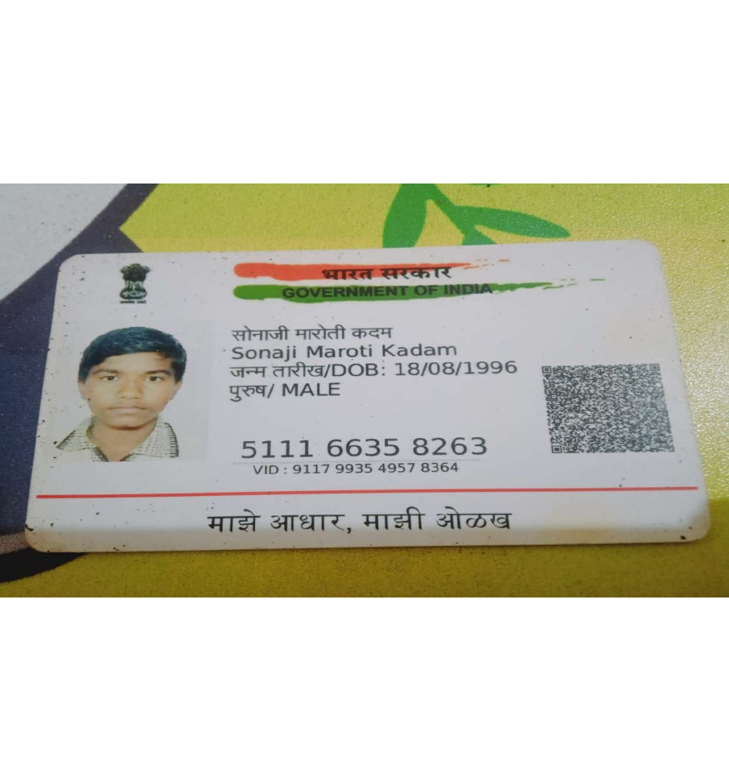

LinkedIn ID: linkedin.com/in/sonaji-kadam-0a2265287

SONAJI KADAM Email : sonajikadam63@gmail.com
AWS DATA ENGINEER Phone No :7499928403

SUMMARY

Data Engineer with a wealth of experience in AWS technologies, Python, SQL, and Pyspark, known for crafting effective data engineering solutions.
- More than 4 years of experience as a Data Engineer in the IT sector.
- Proficiently used AWS services like S3, EC2, Glue, DynamoDB, Lambda, RDS, Redshift, Athena, CloudWatch, SQS, SNS, VPC, IAM, EMR, and Kinesis for data projects.
- Skilled in Python, SQL, PySpark, and Spark-SQL for data processing and analysis.
- Managed various file formats (Text, CSV, JSON, Parquet) using SQL for data transformation and queries.
- Implemented data quality checks and strategies for reliability.
- Expertise in AWS Glue, creating Pyspark scripts for different ETL tasks.
- Utilized Airflow for ETL job organization.
- Automated Glue job triggers using Lambda.
- Proficient in Python (handling exceptions, files, functions, modules, loops) and SQL (views, subqueries, joins, string manipulation, window and date functions).
- Familiar with Spark concepts including Slowly Changing Dimensions, advanced joins, architecture, performance optimization, RDDs, and Dataframes.
- Experienced with query engines, schema cataloging engines, and Warehousing tools such as Athena, Glue.
- SQL concepts including views, subqueries, joins, string operations, window functions, and date functions.
- Familiarity with Hadoop architecture, Hadoop Distributed File System (HDFS), and its components like Name Node, Data Node, Job Tracker, Task Tracker, as well as YARN.
- Knowledgeable about Jenkins, Docker, Kubernetes, and shell scripting for software development and deployment.
- Actively participated in Agile practices, joining Scrum meetings, retrospectives, defect discussions, and grooming sessions across projects.

SKILLS

- AWS Cloud : Glue, EMR, Redshift , Athena, WMAA, S3, IAM , EC2, RDS, VPC, SNS, Lambada, SQS, Cloudwatch, Dynamodb.
- Big Data Ecosystems : Hadoop, HDFS, Hive, PySpark
- Programming Languages : Python , SQL,pyspark
- Data Warehouse : Redshift, Hive
- Orchestration Tool : Airflow, Step Function
- Database : Oracle,mysql
- Operating Systems : Windows and Linux
- File Formats : Parquet, JSON, CSV.
- Tools: Pycharm,Vs Code, Jupyter Notebook, Oracle SQL developer , GIT
- Ticketing Tools : Azure DevOps

WORK EXPERIENCE

Software Engineer at All Safe IT Services | August 2019 - Present

PROJECTS

Project 3
- Client : Optum
- Role : AWS Data Engineer
- Description : Optum has a global presence, serving customers across the healthcare industry, including hospitals, physicians, health plans, life sciences companies.

Responsibilities:
  - Automated triggers and loading processes for ETLGlue jobs using Airflow.
  - Developed Airflow DAGs to effectively manage ETLGlue tasks.
  - Crafted Pyspark scripts, overseeing and monitoring ETL operations.
  - Managed data from diverse sources, including S3.
  - Performed data cleaning and validation procedures.
  - Executed PySpark script transformations within Glue, adhering to SCD2 methodology, and stored the resulting data in S3.
  - Executed Athena queries for testing purposes.
  - Devised and implemented methods to standardize column formats through conversions.
  - Administered Git code repository, handling tasks like code changes, commits, and updates.
  - Engaged in daily Scrum meetings and requirement assessments, analyzing sprint story card requirements.

Project 2
- Client : The Very Group
- Role: Data Engineer
- Description:The Very Group is a multi-brand online retailer and financial services provider in the United Kingdom and Ireland. Its head offices are based in the Speke area of the city of Liverpool, England.

Responsibilities:
  - Developed scheduled ETL Glue tasks for efficient data processing.
  - Crafted Pyspark scripts and oversaw the management and monitoring of ETL operations.
  - Utilized Lambda for triggering ETL jobs.
  - Played a key role in debugging and resolving issues with ETL tasks.
  - Employed Lambda to generate notifications upon event triggers.
  - Conducted data validation on stored S3 data.
  - Managed both loading and unloading of Redshift Data.
  - Devised a data mapping framework for Redshift's data warehouse, executing normalization transformations based on the mapping.
  - Improved the reusability and maintainability of existing Pyspark code through optimizations.

Project 1
- Client : Allegiant Air
- Role: Data Engineer
- Description: Allegiant Air is an American low-cost airline known for offering affordable air travel options primarily to leisure travelers. The airline focuses on serving smaller airports and non-traditional routes, providing a mix of scheduled flights and vacation packages. With a reputation for no-frills service, Allegiant Air aims to provide budget-conscious travelers with access to a range of destinations across the United States.

Responsibilities:
  - Design and optimize database structures, tables, and relationships to ensure effective data storage and retrieval.
  - Execute SQL queries to extract, manipulate, and analyze data stored in databases.
  - Construct data processing workflows using PySpark, integrating RDDs and DataFrame APIs.
  - Employ Python programming expertise to craft scalable scripts for data analysis and manipulation, making use of relevant libraries.
  - Devise enhanced SQL queries and apply optimization techniques to enhance the speed and efficiency of data analysis and retrieval.
  - Demonstrate strong troubleshooting abilities in resolving challenges related to data processing, drawing on expertise in PySpark, SQL, and Python.

EDUCATION

Bachelors of Engineering from Pune University |

